Granulomatous Amebic Encephalitis

What is Granulomatous Amebic Encephalitis (GAE)?

Granulomatous amebic encephalitis (GAE) is a life-threatening progressive infection of the CNS caused by species of the free living ameba genus Acanthamoeba and by the ameba Balamuthia mandrillaris, both ubiquitous in the environment. Single or multiple chronic granulomatous skin lesions may (but not always) be present. The disease has a high case fatality rate, and presents a diagnostic challenge because in many, if not most, cases, patients seek help only when the infection is extensive; this scenario, along with frequent delayed identification (for the reasons above) makes management of the infection even more difficult.
Sappinia pedata: there has been only one case of GAE in the world where the ameba Sappinia pedata was implicated. The information below will apply to GAE caused by species of the genus Acanthamoeba and by the ameba Balamuthia mandrillaris, referred to below as: “Acanthamoeba GAE” and “Balamuthia GAE”.

(Acanthamoeba species can also cause a very serious, sight-threatening infection of cornea known as Acanthamoeba keratitis or AK; which is seen more frequently in the US than Acanthamoeba GAE. AK is presented in another section of this manual)

GAE has an insidious onset: a subacute to chronic onset over several weeks to several months, which ultimately results in the non-specific CNS signs and symptoms described below. This characteristic contributes to the difficulty in diagnosis, and the high case fatality rate. Successful treatment outcomes are possible.

Note: Upon suspicion of this disease, contact The CDC Emergency Operations Center at 770-488-7100 for 24/7 diagnostic assistance, specimen collection guidance, shipping instructions, and treatment recommendations.

General Granulomatous Amebic Encephalitis information:

Because Acanthamoeba GAE and Balamuthia GAE have some overlapping similarities, such as patient immune status, signs and symptoms, brain imaging findings, and routes of infection, this introductory section will provide general facts about GAE.

There are also important differences in the diagnosis and treatment for each type of infection. Acanthamoeba GAE and Balamuthia GAE are described individually, below: to go directly to the specific GAE, click on the blue box titles, below:

Balamuthia GAE: Diagnosis and Treatment

Why Is GAE a diagnostic challenge?
The disease is uncommon, and presents with non-specific features of CNS involvement, GAE is often misdiagnosed, which has contributed to the high cases fatality rate of the disease.
GAE has been mistaken for conditions such as viral encephalitis, bacterial and viral meningitis, stroke, septic emboli, acute disseminated encephalomyelitis, neurotuberculosis, neurocysticercosis, toxoplasmosis, and neoplasms/metastases. In many, if not most, cases, patients seek help only when the infection is extensive; this scenario, along with frequent delayed identification (for the reasons above) makes management of the infection even more difficult.

How is GAE acquired?
GAE is acquired, in almost all cases, by infection from the environment; discussed in detail, below, under each agent.
Cases of GAE caused by solid organ transplant (from Balamuthia mandrillaris) have also occurred.

What are the signs and symptoms of GAE?

In the majority of cases, affected individuals are not aware of the infection, and seek care only at the onset of CNS symptoms, at which time the infection has been progressing for weeks to months.
These symptoms are: ataxia, hemiparesis, periodic seizures, and other symptoms of intracranial hypertension. Confusion, disorientation, and difficulty speaking, are also common signs. Unresponsiveness to verbal and tactile stimuli are also seen. Cranial nerve deficits may or may not be seen.

Fever, headache, nausea, and vomiting will often accompany the CNS symptoms. Sometimes patients, rarely, may present with only these symptoms, or these common symptoms presented with chronic skin lesions, usually seen on the face, extremities and trunk.
This combination of signs and symptoms, with or without CNS symptoms, should help the clinician to think about GAE, and to proceed with a complete history (including occupation and hobby) so a possible exposure could be determined, as part of the diagnostic work-up.

Is it important to obtain a complete history? Because the infection is acquired from the environment, particularly soil, water, and dust, it is very important from a diagnostic perspective to obtain the patient’s history of activities, even going back several months to a year.

What is the incubation time for GAE? It is believed to be weeks to months. It is often quite difficult to determine, due to the ubiquitous nature of both organisms.
Cases due to organ transplantation have a much more rapid onset of symptoms; as quickly as 18 days post-transplant.

Does GAE occur only in immunocompromised people?
No, both immunocompromised and immunocompetent people can be infected. Specific differences between Acanthamoeba GAE and Balamuthia GAE regarding immune status of patients is shown below, under each infection.

What are the brain imaging findings in GAE?

No imaging pattern with CT or MRI appears to be specific for GAE.

CT: Multiple enhancing lesions can be demonstrated. Non-contrast enhanced and contrast-enhanced CT can reveal lesions, such as hyperattenuated lesions. Contrast-enhanced CT can reveal ill-defined pseudotumoral lesions.
Peri-lesional edema can also be seen.
MRI: Multiple or single non-specific, well-defined ring-enhancing and space-occupying lesions, multifocal lesions, edema, and lesions appearing as brain abscesses or tumors have been observed.
Peripheral ring-enhancing lesions similar to neurocysticercosis and neurotuberculosis may be seen.
(T1 and T2 -weighted images)
These can be seen throughout the brain, with no predilection for a particular region; the cerebrum, cerebellum, brain stem have contained these lesions. The parietal and occipital lobes commonly contain these lesions.
Multiple punctate focal areas of enhancement have been observed bilaterally throughout the cerebellar hemispheres, with some scattered foci supratentorially.

Progression or increase in the number of lesions has been observed when corticosteroids and other immunosuppressants are administered to the patient.

Acanthamobea GAE: Diagnosis and Treatment

Acanthamoeba GAE presents a diagnostic and treatment challenge for the clinician because awareness of the disease is extremely low due to the low prevalence of confirmed cases, and due to the non-specific signs and symptoms which mimic a variety of more common conditions.
In many, if not most, cases, patients seek help only when the infection is extensive; this scenario, along with frequent delayed identification (for the reasons above) makes management of the infection even more difficult.

The mortality rate is over 85%, and most cases are diagnosed post-mortem.
GAE due to Acanthamoeba species is more common than Balamuthia GAE (below) in the US.

(Acanthamoeba species also cause a disseminated disease associated with hematogenous spread, often from the respiratory system to the skin and multiple organ systems, with or without GAE, and cutaneous acanthamoebiasis. This form is seen most often in infected patients with AIDS; the lesions may precede GAE, and therefore would be a useful diagnostic aid. These two conditions are not discussed separately here)

The first step in diagnosis is to think of it.

Patient history plays a significant role in the diagnosis.

Environmental reservoirs and routes of infection:.

Acanthamoeba species are ubiquitous in the environment; they have been found in soil, dust, air, field-grown vegetables; fresh, brackish, and sea water; in bottled and mineral water, in sewage, swimming pools, in tap water and residential plumbing, in heating, ventilating, and air conditioning systems, humidifiers, among other reservoirs. They have also been found in recalled contact lens solutions, and personal contact lens care equipment, such as lens cases in everyday use.
They can also be found in medical and dental settings, including medical and surgical equipment, therapeutic pools, in dialysis units (in the dialysis machines), and dental treatment units. Nosocomial infections can occur; specimens in health care settings could harbor these organisms; as they are found in nose, throat, sinus, urine and sputum in hospitalized individuals

Acanthamoeba enters the body through various means. In most cases of Acanthamoeba GAE, entry occurs either through the nasal passages (and then to the lower respiratory tract), or through ulcerated or broken skin. When Acanthamoeba enters the eye it can cause severe keratitis in otherwise healthy individuals, particularly contact lens users. Acanthamoeba keratitis or AK, is presented in another section of this manual.

When Acanthamoeba enters the body through the respiratory system or through skin lesions, it spreads hematogenously to other organ systems, including the central nervous system, causing granulomatous amebic encephalitis (GAE). Chronic skin lesions may also appear and can be clinical indicators of imminent CNS involvement.

Acanthamoeba species; known routes of infection

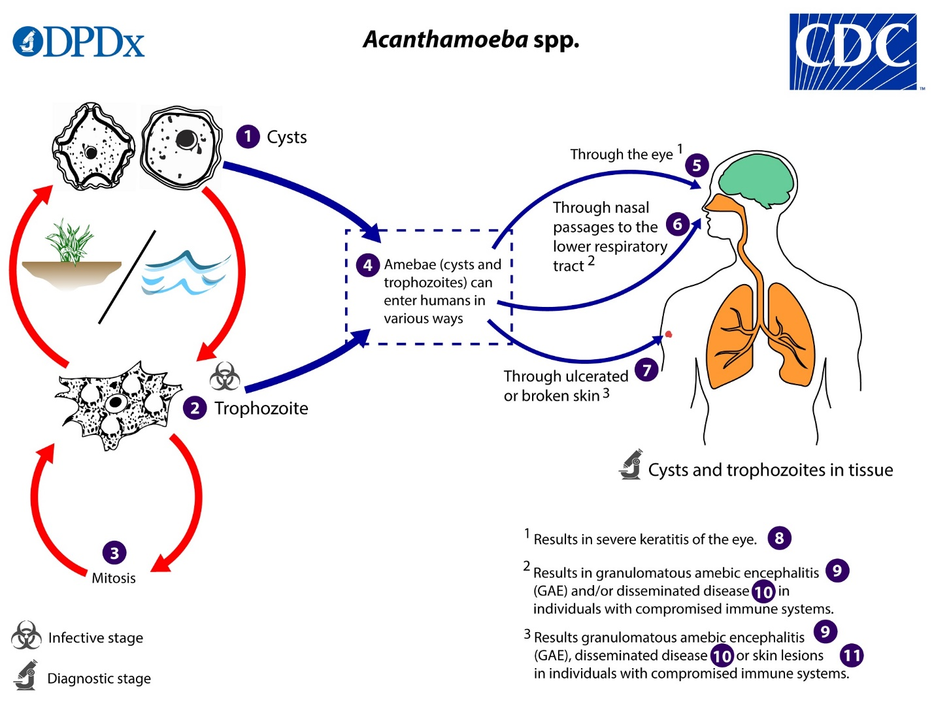
Courtesy, CDC.
(from https://www.cdc.gov/dpdx/freelivingamebic/modules/Acanthamoeba_LifeCycle_lg.jpg )

Patient profile:

GAE due to Acanthamoeba can occur in immunocompetent patients, but is more often seen in those who have compromised immune systems due to a variety of conditions or medical procedures:
- advanced AIDS
- agammaglobulinemia
- lymphoproliferative disorders
- chemotherapy
- organ/tissue transplant recipients (including bone marrow recipients)
- those who are receiving steroid treatment for other conditions
- patients with debilitating and/or chronic conditions such as diabetes, renal failure, liver cirrhosis, malnutrition, alcohol or other substance abuse

Signs and Symptoms:

The list directly below includes those seen early in the disease, preceding CNS symptoms, as well as concurrent with CNS signs:
- Fever
- Headache
- Nausea
- Vomiting
- Chronic skin lesions (not in all cases)

The skin lesions may precede the onset of CNS manifestations by weeks to months and those associated with GAE are typically firm, erythematous nodules which are scattered anatomically, and may ulcerate or drain purulent material.
These lesions may indicate imminent CNS involvement; diagnosis of the infection through skin lesion biopsy (below) has many obvious advantages.

CNS:

Specific signs and symptoms will depend on the area of the brain affected; often the GAE presentation is similar to those seen in patients with:

- space-occupying lesions:
seizures
hemiparesis
cranial nerve palsies

- Signs mimicking Cerebrovascular ischemia, including:
slurred speech
hemiparesis
dizziness
confusion
ataxia

- Signs similar to bacterial or viral meningitis/encephalitis:
hallucinations
nucchal rigidity
Brudzinsky and Kernig signs

Differential diagnosis:

- Aspergillosis
- Bacterial Conjunctivitis (Pink Eye)
- Coccidioidomycosis and Valley Fever
- Cryptococcosis
- Herpes Simplex
- Herpes Simplex Virus (HSV) Keratitis
- Histoplasmosis
- Neurocysticercosis
- Nocardiosis
- Progressive multifocal leukoencephalopathy
- Toxoplasmosis
- Tuberculosis (TB)

Non-infectious:

- Stroke
- Neoplasm
- Multiple Sclerosis

Imaging:

Ring-enhancing lesions; early stages may present with a single lesion but as the infection progresses, multiple lesions will form. These can be seen in the cerebrum, cerebellum, brain stem and spinal cord. Parietal , temporal, and occipital lobes are common locations.
CT and MRI findings have been suggestive of abscesses and tumors.

MRI images:

Fatal Granulomatous Amoebic Encephalitis Caused by Acanthamoeba in a Patient With Kidney Transplant: A Case Report

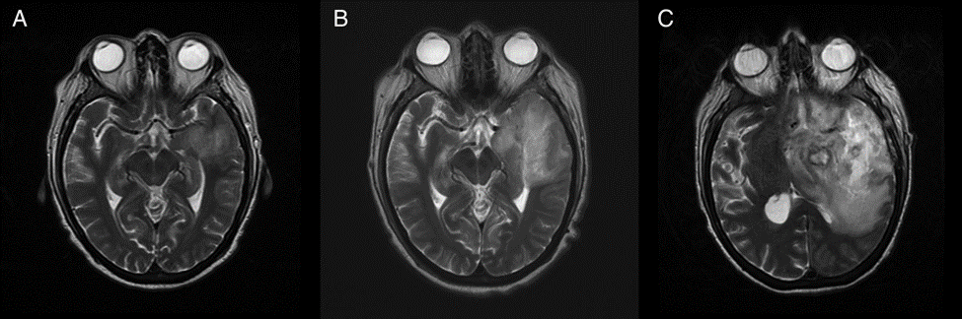

T2 brain magnetic resonance imaging.

Images from a case report of a 64 yr old woman who underwent uneventful deceased donor kidney transplantation. Seven months post-transplant she presented with confusion.
Images taken (noncontrast CT and MRI) at this first episode were negative.

The images above were taken 10 days after her first episode of confusion.

(A–C) T2 brain magnetic resonance imaging of the patient with granulomatous amoebic encephalitis caused by Acanthamoeba. Brain imaging demonstrates progressive changes of cerebritis visible as T2 hyperintensity with mass effect that initially involves the anterior temporal lobe progressing to affect most of the left cerebral hemisphere, with increased mass effect and multiple areas of necrosis. This was associated with patchy cytotoxic edema and focal, subtle enhancement with a tiny single focus of necrosis. There were multiple microhemorrhages within and remote from this region.

Above images from: Fatal Granulomatous Amoebic Encephalitis Caused by Acanthamoeba in a Patient With Kidney Transplant: A Case Report
Ahmad Salameh, Nancy Bello, Jennifer Becker, Tirdad Zangeneh
Open Forum Infectious Diseases, Volume 2, Issue 3, Summer 2015, ofv104, https://doi.org/10.1093/ofid/ofv104
Published: 10 July 2015

Lab analysis of CSF:

CSF analysis often shows a pleocytosis with lymphocytic predominance, elevated protein, and low glucose.
Acanthamoeba trophozoites (infective, feeding form of the organism) and cysts (dormant, resistant form) may only rarely be found in a wet mount of spinal fluid; and may easily be mistaken for inflammatory WBC. Wright stain of CSF sediment after centrifuge distinguishes the organism, if present, from inflammatory cells. Appearance is small pale blue nucleus occupying approximately one-sixth of the cytoplasm.
Trophozoites may also be observed in trichrome stained bronchoalveolar lavage specimens.

Pathogen Identification/ laboratory detection:

Tissue specimens may be sent to CDC for testing, upon consultation. These may include brain or skin biopsy specimens, serum, and CSF.

Contact The CDC Emergency Operations Center at 770-488-7100 for 24/7 diagnostic assistance, specimen collection guidance, shipping instructions, and treatment recommendations.

PCR testing is conducted at CDC; guidance on specimen types and collection is provided by the office directly above.

CDC has developed a website, https://www.cdc.gov/dpdx/contact.html to assist in the diagnosis of parasitic diseases, which includes specimen identification assistance.

Requirements for submitting specimens are here: https://www.cdc.gov/parasites/naegleria/pdf/Free-Living-Ameba-Testing-Factsheet-508c.pdf

At the hospital level, an experienced microbiologist/pathologist may have success with tissue biopsies stained with hematoxylin and eosin (H&E) or Wright stain may distinguish trophozoites and cysts by characteristic nuclear morphology (a “halo” around the chromatin) from surrounding cells.
Cysts may be distinguished by staining with Periodic acid-Schiff (red cyst wall), Gomori-methenamine silver (black cyst), and calcofluor white (fluorescent cysts).
Treatment:

It is advisable to contact CDC for treatment guidance. Successful cases have been treated with the following agents, used alone or in combination.:

- Impavido® (miltefosine),
- azoles (ketoconazole, fluconazole,
voriconazole, itraconazole),
- amphotericin B,
- flucytosine,
- caspofungin,
- sulfadiazine
- pentamidine isethionate,
- azithromycin,
- penicillin,
- chloramphenicol,
- rifampicin

Impavido® (Miltefosine) is in stock in the hospital pharmacy
https://www.profounda.com/

Balamuthia GAE: Diagnosis and Treatment

Balamuthia GAE is an insidious CNS infection with a high mortality rate. It is caused by the free-living ameba Balamuthia mandrillaris, which was identified and named in 1990. It is the only known species of the genus. Infection occurs from exposure to contaminated soil and possibly untreated fresh water.
Like Acanthamoeba GAE, Balamuthia GAE presents a diagnostic and treatment challenge for the clinician because awareness of the disease is extremely low due to the low prevalence of confirmed cases, and due to the non-specific signs and symptoms which mimic a variety of more common conditions.

In many, if not most, cases, patients seek help only when the infection is extensive; this scenario, along with frequent delayed identification (for the reasons above) makes management of the infection even more difficult.

Balamuthia mandrillaris primarily affects 2 organ systems in humans: the skin and the CNS.

Symptoms can appear mild at first but can progress over weeks to months. Infection can also
occur from exposure to the agent from infected solid organ transplant.
Balamuthia GAE can also present initially with a local skin lesion or lesions, in the absence of CNS signs and symptoms, which are exhibited later in the disease course.

History taking:
Of upmost importance is the taking of a complete history- the patient’s occupation(s), hobbies, and travel over the past few years can be very helpful. Travel and residence in dry, dusty areas are risk factors; the southwest US has more cases than other regions of the US. Gardening and landscaping are risk factors; patients with Balamuthia GAE have been involved in these activities, having been infected from contaminated soil and dust.
Survival, with no detectable neurologic deficit is possible with the optimal drug regimen (below). (https://www.ncbi.nlm.nih.gov/pmc/articles/PMC5330223/ )

A Balamuthia survivor
Michael Eric Vollmer and Carol Glaser
JMM Case Rep. 2016 Jun; 3(3): e005031.
Published online 2016 Jun 28. doi: 10.1099/jmmcr.0.005031

The mortality rate is 90%.

This infection is less common than Balamuthia GAE, with 109 documented cases from 1974 through 2016.

Environmental reservoirs and routes of infection:

The environmental niche of Balamuthia mandrillaris is not well defined. It has been isolated from soil, dust, and water. The exact ecologic niche of Balamuthia mandrillaris remains unknown.

Exposure to Balamuthia might be common, although disease caused by Balamuthia is rare.

Infection is thought to occur by inhalation of airborne cysts or through direct contamination of a break in the skin. GAE is thought to occur when organisms then travel from the lower respiratory tract, sinuses, or skin to the meninges and brain by the hematogenous route.

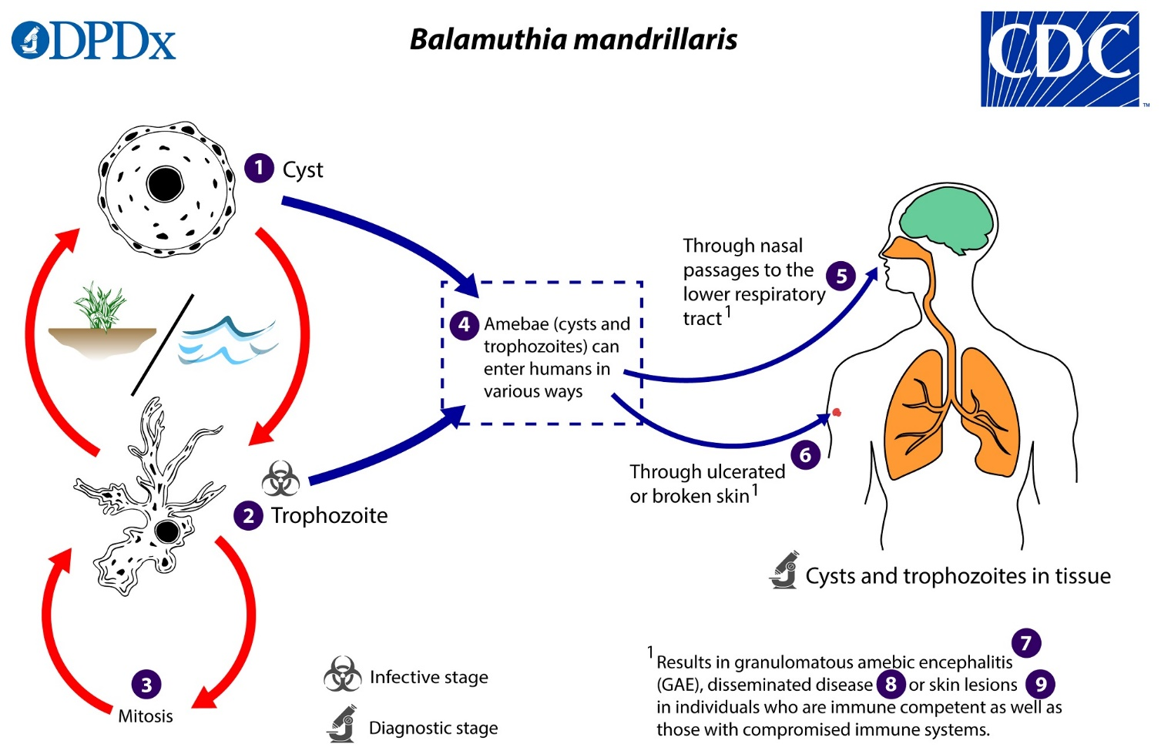

Courtesy: CDC
https://www.cdc.gov/dpdx/freelivingamebic/index.html

Patient profile:

Both immunocompetent and immunocompromised people are infected; unlike Acanthamoeba GAE, where the majority of cases are with immunocompromised patients.

From the epidemiological study of Balamuthia mandrillaris conducted by Dr. Jennifer Cope, et. al (reference below): The Epidemiology and Clinical Features of Balamuthia mandrillaris Disease in the United States, 1974–2016:
of the 109 cases surveyed during the specific time period, the median age was 36 years (range 4 months to 91 years). Males accounted for 68% of the case patients. California had the highest number of case reports, followed by Texas and Arizona.

Hispanics constituted 55% for those with documented ethnicity. Exposure to soil was commonly reported. Among those with a known outcome, 90% of patients died.

Signs and Symptoms:

The incubation period of Balamuthia granulomatous amebic encephalitis (GAE) is unknown although, in disseminated infections with preceding cutaneous involvement, a few weeks to about 2 years may elapse between the appearance of skin lesions and the recognition of central nervous system (CNS) disease.
Patients exposed through solid organ transplantation can develop symptoms of Balamuthia GAE more quickly, within a few days to weeks (range 12–24 days), possibly because of direct inoculation and immunosuppression.
GAE symptoms can appear mild at first but can progress over weeks to months.

Symptoms:

Personality and mental status abnormalities may be expressed, alone or in combination with:

- headache,
- stiff neck,
- photophobia,
- nausea,
- vomiting,
- lethargy,
- fever,
- ataxia,
- diplopia,
- impaired speech,
- focal neurologic deficit,
- seizures

Additional symptoms:

- Weight loss
- Partial paralysis

Some patients with Balamuthia GAE have presented with rhinitis with sinus infections, otitis media, and/or skin lesions.

Skin lesions:

Skin lesions are often seen on the face (particularly involving the nose or cheek) but also on the torso or limbs. In patients with cutaneous involvement, most generally have a single lesion, but multiple lesions are also seen. These lesions are chronic and granulomatous in nature, beginning as papulonodular, erythematous, plate-like areas that enlarge over time. The lesions are typically painless but can ulcerate and cause tissue destruction. Involvement of the oral cavity, especially of the palate, may also be present. Most patients with Balamuthia skin lesions later develop GAE.

When Balamuthia is suspected, a careful skin exam should be conducted, as detection of a lesion consistent with cutaneous balamuthiasis might allow for early diagnosis on easily accessible tissue. Additionally, Balamuthia should be considered as an infectious etiology for one or more chronic skin lesions and as an etiology for meningitis/encephalitis in the presence of a skin lesion, particularly in the presence of other epidemiologic clues, such as Hispanic ethnicity, soil or water exposure, residence in or travel to the southwest United States, and male sex although such factors need not be present for Balamuthia to be in the differential diagnosis.

However, many people with Balamuthia GAE (including most cases identified in the U.S.) never develop preceding skin lesions. (CDC unpublished data).

Differential diagnosis:

• Aspergillosis
• Acute disseminated encephalomyelitis
• Coccidioidomycosis and Valley Fever
• Cryptococcosis
• Herpes Simplex
• Herpes Simplex Virus (HSV) Keratitis
• Histoplasmosis
• Neurocysticercosis
• Nocardiosis
• Progressive multifocal leukoencephalopathy
• Toxoplasmosis
• Tuberculosis meningitis (TB)
• Brain abscess
• Septic emboli
• Viral encephalitis

Non-infectious:

• Stroke
• Neoplasm/metastases
• Multiple Sclerosis

Imaging:

CT and MRI will most likely reveal enhancing lesions, multifocal lesions, and edema.
Lesions were located throughout the brain with no predilection for a particular region.

Lab analysis of CSF:

Most patients in the survey by Cope, et al, referenced above, had a mildly elevated WBC, with a lymphocytic predominance (usually less than 500 cells/mm³), elevated protein, and normal to low glucose.
Balamuthia organisms are rarely seen in the CSF.

Pathogen Identification/ laboratory detection:

Diagnostic testing is not widely available for Balamuthia infection. Clinicians who suspect Balamuthia infection should contact their state health department and/or CDC (24/7 Emergency Operation Center—770-488-1700). CDC can assist with diagnosis and provide treatment recommendations. Telediagnosis can be arranged at CDC by emailing photos through DPDx, CDC’s telediagnosis tool. Instructions for submitting photos through DPDx are available at the DPDx Contact Us page: . https://www.cdc.gov/dpdx/

For diagnostic tests offered by CDC, and additional specimen submission information, refer to this page: https://www.cdc.gov/parasites/balamuthia/diagnosis-hcp.html

Brain and skin (where possible) biopsy specimens are utilized, as well as CSF.

Diagnostic Tests that can possibly be performed in the hospital lab are:

Direct Visualization:

CSF: Balamuthia trophozoites and/or cysts are rarely seen in the CSF. Every effort should be made to obtain brain tissue in order to make the diagnosis of Balamuthia GAE. If Balamuthia is identified in the CSF, the diagnosis of GAE should be subsequently confirmed with PCR or immunohistochemical tests of the CSF because host cells can be mistaken for Balamuthia. Note that a negative test on CSF does not rule out Balamuthia infection because the organism is not commonly present in the CSF.
Tissue: The diagnosis of Balamuthia infection can be made by microscopic examination of tissue sections from biopsy specimens (skin lesions or brain tissue) stained with hematoxylin and eosin (H&E) or periodic acid-Schiff (PAS)⁶ which might demonstrate trophozoites and/or cysts with morphology typical of Balamuthia (Figures A–D).
The cysts of Balamuthia mandrillaris are 6–30 µm in diameter (Figure A and B).Under a light microscope, the cysts appear to have two walls: a wrinkled fibrous outer wall (exocyst) and an inner wall (endocyst) that may be hexagonal, spherical, star-shaped or polygonal.Refractile granules might be observed below the inner wall. Pores are not evident in the wall complex. Cysts usually contain only one nucleus but occasionally have two nuclei.
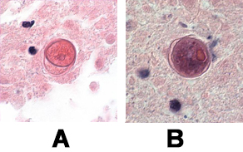
A, B: Cysts of B. mandrillaris in brain tissue, stained with H&E. Images courtesy of the University of Kentucky Hospital, Lexington, Kentucky.
Trophozoites of Balamuthia mandrillaris are pleomorphic and measure approximately 12–60 µm (Figure C and D). They often produce long, slender pseudopodia. Trophozoites are usually uninucleate but binucleate forms are sometimes seen. The nucleus contains a large, centrally-located nucleolus but two or three nucleoli have been seen, especially in infected tissues; when present, multiple nucleoli distinguish B. mandrillaris from Acanthamoeba spp. There is no flagellated trophozoite stage as in Naegleria spp. ^{3,6,7}.
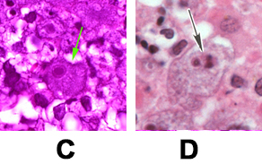
C, D: Trophozoites of B. mandrillaris in brain tissue, stained with H&E.
Biopsies of skin lesions demonstrate granulomatous inflammation with infiltrating giant cells, lymphocytes, plasma cells, and eosinophils; Balamuthia cysts or trophozoites can often be seen in tissue sections ⁸. Although most lesions are found in the skin or the brain, granulomas containing amebae have also been found in other organs including the lungs and kidneys.
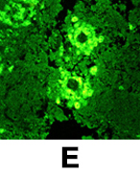
E: Indirect Immunofluorescence (IIF) assay for Balamuthia mandrillaris.

PCR:

An increasing number of PCR-based techniques (conventional and real-time PCR) have been described for detection and identification of free-living amebae in clinical samples, but are only available in selected reference laboratories. A real-time PCR was developed at CDC for simultaneous identification of Balamuthia mandrillaris, Naegleria fowleri, and Acanthamoeba species in clinical samples. This assay uses distinct primers and TaqMan probes for the simultaneous identification of these three amebae. Culture may be used to amplify the number of organisms for PCR testing, but is not used alone for diagnostic testing. Unlike Acanthamoeba, Balamuthia cannot be grown on agar plates coated with bacteria but requires mammalian cell cultures (such as monkey kidney [E6] or human lung fibroblasts) for laboratory cultivation.

Antigen Detection:

Detecting Balamuthia mandrillaris antigen involves immunohistochemical staining techniques, such as indirect immunofluorescence (IIF) staining and immune alkaline phosphatase staining (IHC), which use an antibody specific for Balamuthia mandrillaris followed by microscopic examination to identify Balamuthia mandrillaris in tissue, culture, or CSF.
Immunohistochemical (IHC) techniques employing rabbit anti-ameba sera. with subsequent microscopic examination can identify Balamuthia in tissue, culture, or CSF. Three IHC methods are available: indirect immunofluorescence (IIF) staining (Figure E), immune peroxidase staining, or immune alkaline phosphatase staining.

Serology:

Antibodies have been demonstrated in healthy persons and patients with Balamuthia infection. Serology using an immunofluorescent antibody test for Balamuthia is available at CDC as a research technique, as it has not been evaluated for use as a routine diagnostic procedure.

Treatment:
The following CDC recommendations are based on the small number of Balamuthia survivor case reports in the literature. The table below is from:
https://www.cdc.gov/parasites/balamuthia/treatment-hcp.html
The following combination of five drugs has been successfully given to the few survivors of Balamuthia GAE and should be given in combination to a patient with suspected or confirmed Balamuthia GAE:

Recommended Treatment for Granulomatous Amebic Encephalitis Caused by Balamuthia mandrillaris^{A}

Drug | Dose | Notes
Pentamidine ^{1–3} (IV) | 4 mg/kg given once per day | Although pentamidine has amebastatic activity in vitro and has been used successfully in the past in combination with the drugs listed below, pentamidine is very toxic and doesn’t cross the normal, intact blood-brain barrier well so its use must be a clinical decision ⁴.
Sulfadiazine ^{1–3} (oral) | 1.5 g every 6 hours in adults; 200 mg/kg/day in 4–6 doses in pediatric patients (maximum 6 g/day)
Flucytosine ^{1, 3} (oral) | 37.5 mg/kg every 6 hours (maximum 150 mg/kg/day)
Fluconazole ^{1–3, 5} (oral or IV) | 12 mg/kg/day in one dose
Azithromycin ^{1, 3} (oral or IV) ª Clarithromycin ^{2, 5} (oral) ª | 20 mg/kg/day in 1 dose (max 500 mg/day) in pediatric patients; 500 mg/day in 1 dose for adults
 | 14 mg/kg/day in 2 doses (max 2 g/day) | Alternative to azithromycin
Miltefosine ^{5–7} (oral) ^{b} | Up to 45 kg body weight: 100 mg daily (i.e., one 50 mg cap po with breakfast and dinner)  For pediatric cases, 2.5 mg/kg/day up to 100 mg daily  45 kg body weight and higher: 150 mg daily (i.e., one 50 mg cap po with breakfast, lunch, and dinner) ^{c} | ^{d}  Impavido® (Miltefosine) is in stock in the hospital  pharmacy https://www.profounda.com/
^{A} Duration of treatment has not been established. In case reports of survivors, duration of treatment has ranged from several weeks to several months or even years. The decision to stop treatment should be made on a case-by-case basis and include consideration of the patient’s clinical status and review of laboratory and radiographic findings. Empiric trials of amphotericin B have not been successful.

a Azithromycin has been used successfully in combination therapy to treat Balamuthia infection but was changed in some cases to clarithromycin 1 because of persistent elevation of creatinine levels (concern about interstitial nephritis with azithromycin), and potentially better penetration of clarithromycin into the cerebrospinal fluid; however, in vitro studies indicate that azithromycin is more active than clarithromycin against other free-living amebae (Naegleria).

b Recently, miltefosine, an anti-leishmania drug, has shown some promise in combination with some of these other drugs. Miltefosine has shown good in vitro amebicidal activity against Balamuthia and has been used to successfully treat a few patients with Balamuthia GAE and disseminated Acanthamoeba (another free-living ameba) in combination with some of the drugs listed above. The standard miltefosine dosing recommended for the treatment of leishmaniasis is presented in the table. Unfortunately, the oral preparation is the only formulation available.

c The standard doses of miltefosine listed above are the maximal tolerated with respect to gastrointestinal symptoms. A higher dose would lead to increased nausea, vomiting, or diarrhea. Miltefosine is mildly nephrotoxic but is not cleared by the kidneys; therefore, dosing does not need to be adjusted for patients with impaired renal function. Because little data are available about the effective dose for amebic infection, the risk for nephrotoxicity should be balanced with the risk for mortality from GAE or disseminated disease.

d Miltefosine (Impavido®) is in stock in the hospital pharmacy https://www.profounda.com/

Although Balamuthia GAE is often fatal, there are several recorded cases of Balamuthia infection in the United States in which the patient survived after long-term treatment with multiple drugs; a few survivors have also been reported in other countries. All of the U.S. survivors had GAE; some of the survivors had excisional biopsies of one of their multiple brain lesions. At least one survivor had an accompanying cutaneous lesion In some of the US cases, the patients were able to return to normal functioning with no reported sequelae. Early diagnosis and treatment might increase the chances for survival.

References:

Case study
Lethal encounters: The evolving spectrum of amoebic meningoencephalitis
Sandra G.Gomp^{a,b}, CristinaGarcia^{a,b}
IDCases
Volume 15, 2019, e00524

a
James A. Haley Veterans Hospital, 13000 Bruce B. Downs Blvd., 33612, Tampa, FL, United States
b
University of South Florida Morsani College of Medicine, 12901 Bruce B. Downs Blvd., Tampa, FL 33612, United States

https://doi.org/10.1016/j.idcr.2019.e00524

The Epidemiology and Clinical Features of Balamuthia mandrillaris Disease in the United States, 1974–2016
Jennifer R Cope, Janet Landa, Hannah Nethercut, Sarah A Collier, Carol Glaser, Melanie Moser, Raghuveer Puttagunta, Jonathan S Yoder, Ibne K Ali, Sharon L Roy
Clinical Infectious Diseases, Volume 68, Issue 11, 1 June 2019, Pages 1815–1822, https://doi.org/10.1093/cid/ciy813
Published: 21 September 2018
https://academic.oup.com/cid/article/68/11/1815/5104175

Acanthamoeba spp. as Agents of Disease in Humans
Francine Marciano-Cabral* and Guy Cabral
Clin Microbiol Rev. 2003 Apr; 16(2): 273–307.
doi: 10.1128/CMR.16.2.273-307.2003
https://cmr.asm.org/content/16/2/273.long

